DECODE E-COMMERCE ORDERS
- To check the Table
SELECT * FROM [Decode_ECommerce_Orders]
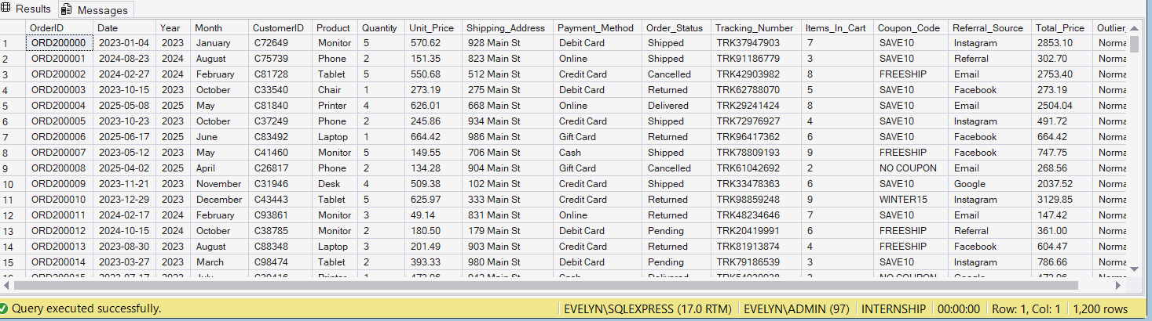
- To view specific columns
SELECT OrderID, Product,Total_Price, Order_Status FROM [Decode_ECommerce_Orders]
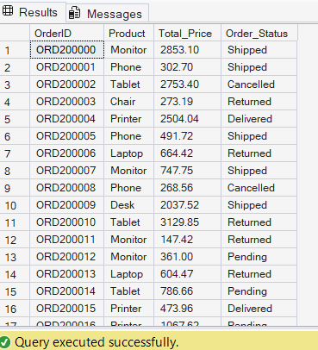
- Top highest value orders
SELECT TOP 10 OrderID, Product, Quantity, Total_Price FROM [Decode_ECommerce_Orders]
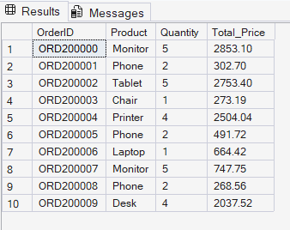
- Orders that were delivered;
SELECT * FROM [Decode_ECommerce_Orders] WHERE Order_Status = 'Delivered'
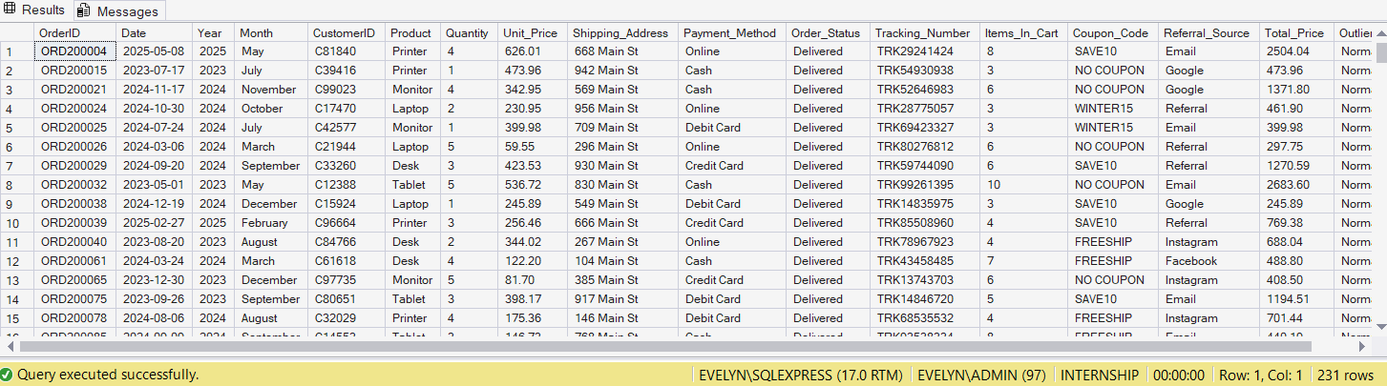
- Orders above $3,000
SELECT * FROM [Decode_ECommerce_Orders] WHERE Total_Price > 3000
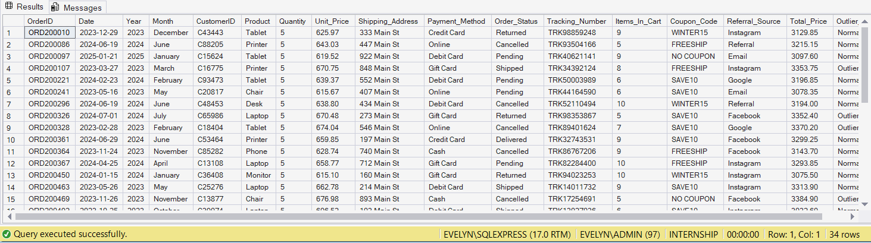
- Outlier Orders (Above upper fence)
SELECT * FROM [Decode_ECommerce_Orders] WHERE Total_Price > 3330.41
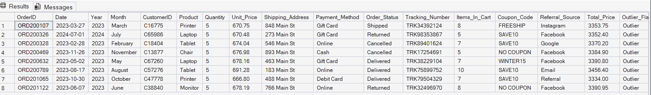
- Cancelled OR Returned Orders
SELECT * FROM [Decode_ECommerce_Orders] WHERE Order_Status = 'Cancelled' OR Order_Status = 'Returned'
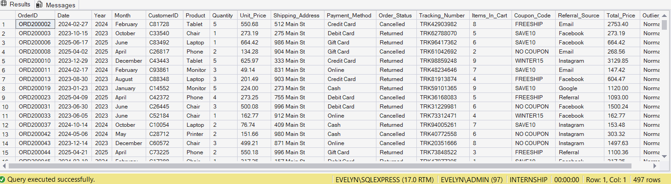
- Instagram orders paid by Credit card;
SELECT * FROM [Decode_ECommerce_Orders] WHERE Referral_Source = 'Instagram' AND Payment_Method = 'Credit Card'
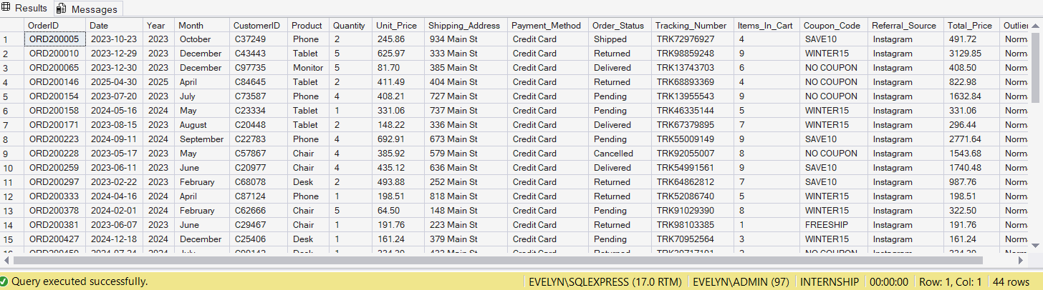
- Orders with No Coupon used
SELECT * FROM [Decode_ECommerce_Orders] WHERE Coupon_Code = 'NO COUPON'
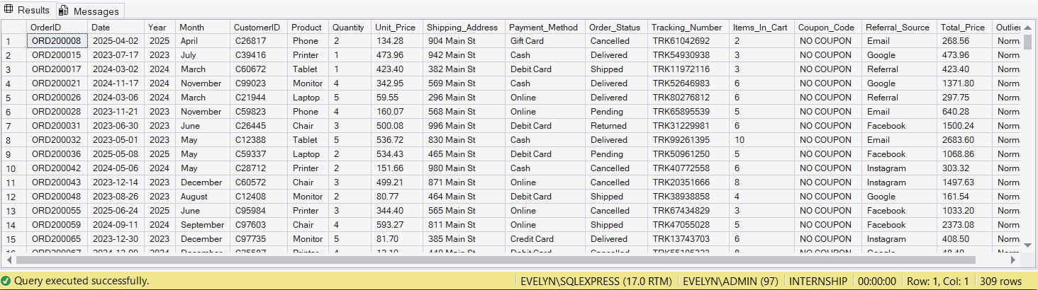
- Total Revenue, Orders, Avg Order Value by Product
SELECT Product,
COUNT(*) AS TotalOrders,
SUM(Total_Price) AS TotalRevenue,
AVG(Total_Price) AS AvgOrderValue
FROM [Decode_ECommerce_Orders]
GROUP BY Product;
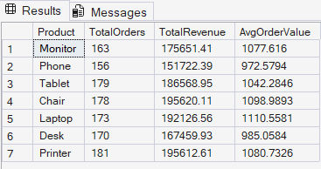

- Order count by Order status
SELECT Order_Status,
COUNT(*) AS OrderCount
FROM [Decode_ECommerce_Orders]
GROUP BY Order_Status
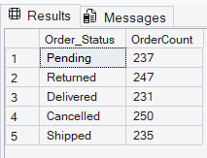

- Revenue by Referral source
SELECT Referral_Source,
COUNT(*) AS Orders,
SUM(Total_Price) AS TotalRevenue,
AVG(Total_Price) AS AvgOrderValue
FROM [Decode_ECommerce_Orders]
GROUP BY Referral_Source
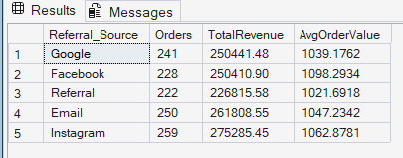

- Revenue by Payment method
SELECT Payment_Method,
COUNT(*) AS Orders,
SUM(Total_Price) AS TotalRevenue,
AVG(Total_Price) AS AOV
FROM [Decode_ECommerce_Orders]
GROUP BY Payment_Method
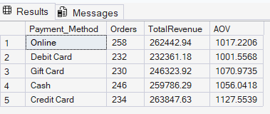

- Overall Basic Statistics
SELECT
COUNT(*) AS TotalOrders,
SUM(Total_Price) AS TotalRevenue,
AVG(Total_Price) AS AvgOrderValue,
MIN(Total_Price) AS SmallestOrder,
MAX(TOTAL_Price) AS LargestOrder
FROM [Decode_ECommerce_Orders]
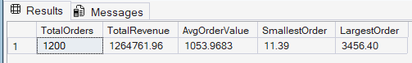

- Count cancelled and Returened Order
SELECT
COUNT(*) AS 'FailedOrders'
FROM [Decode_ECommerce_Orders]
WHERE Order_Status IN ('Cancelled', 'Returned')
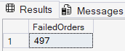
- Average Order Value with VS without Coupon
SELECT
CASE WHEN Coupon_Code = 'NO COUPON'
THEN 'NO COUPON'
ELSE 'HAS COUPON'
END AS Coupon_Code,
COUNT(*) AS Orders,
AVG(Total_Price) AS AOV
FROM [Decode_ECommerce_Orders]
GROUP BY
CASE WHEN Coupon_Code = 'NO COUPON' THEN 'NO COUPON'
ELSE 'HAS COUPON'
END
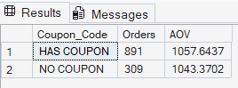

- Products ranked by Total Revenue (highest first)
SELECT Product,
SUM(Total_Price) AS TotalRevenue
FROM [Decode_ECommerce_Orders]
GROUP BY Product
ORDER BY TotalRevenue DESC
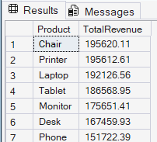

- Cheapest Orders first
SELECT OrderID, Product, Total_Price FROM [Decode_ECommerce_Orders]
ORDER BY Total_Price ASC
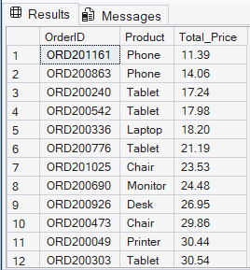

- Most recent Orders first:
SELECT OrderID, Date, Product, Total_Price FROM [Decode_ECommerce_Orders]
ORDER BY Date DESC
